From: 3, Ehoro Crescent, Elelenwo Rivers.
10/6/2024

To: OptimusBank Ltd Yaba Branch.

Dear Manager,

INSTRUCTION TO LIǪUIDATE

Please take this as an instruction to liquidate all my outstanding loan with your bank.

Here is my account details.

Account Name: NNAMDI JOSEPH EGERUE Account number: 1000036233

Thank you in anticipation.

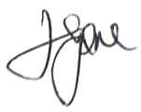

NNAMDI JOSEPH EGERUE

